CIS11 Lab 3: Operation and Data Movement

In this lab, we will program instructions in LC-3 to create simple assembly program for operation and data movement purposes. Refer to LC-3 tutorial and Lab 2 for basic LC-3 Simulator setup and usage instructions.

Arithmetic Instructions
- In this exercise, we will create a subtraction program. Open LC-3 Editor and write the following program:
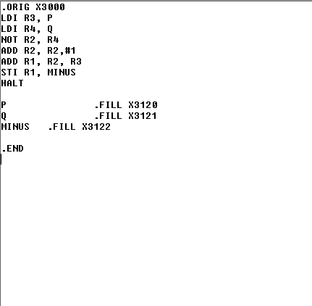
Include appropriate comments. Save the program as Lab3Ex1.asm, then Assemble the program. After the program is Assembled, Load Program (.obj) file and Run the program. Review LC3 Simulator and answer the following questions.
- Provide screen captures that contain code from the Editor and Simulator after the program has been loaded and ran.
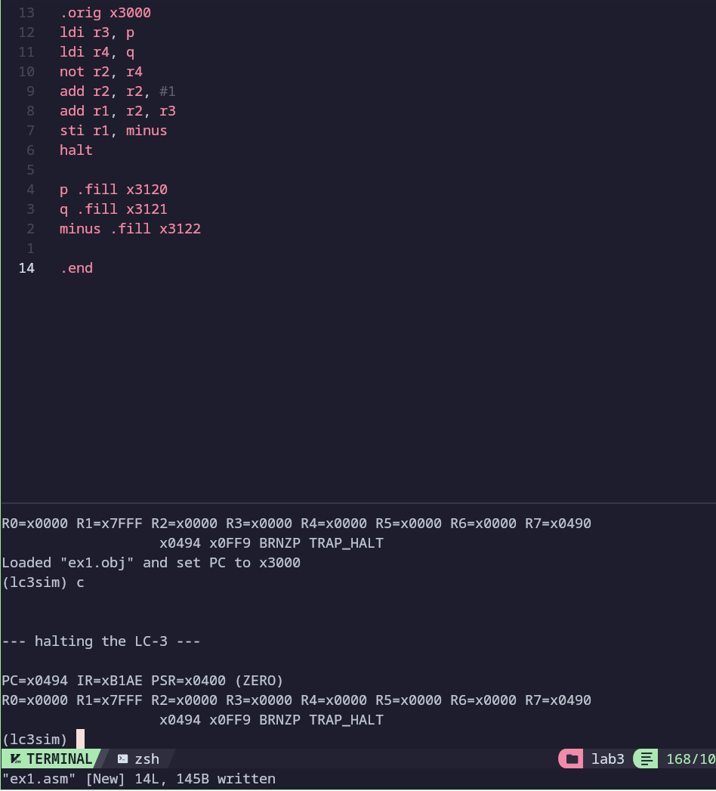
- Identify the addresses for P, Q and the result.
X3120, x3121, x3122
- Why is the LDI instructions used to load the values of P and Q?
LDI loads a value from the location stored in the memory location of it’s input
- Why is the STI instructions used to store the result in P_minus_Q?
It is used to store the result of the operation to the location pointed to by the pointer ad minus
- Which Register is used to store the result?
r1

- Create an assembly program that performs the following calculation:

X =(Y +1) - Z
X can be found in memory location x3225. Y and Z can use any memory location. Save file as Lab3Ex2.asm. Assemble, load and run the program.
- Provide screen captures of code and simulator.
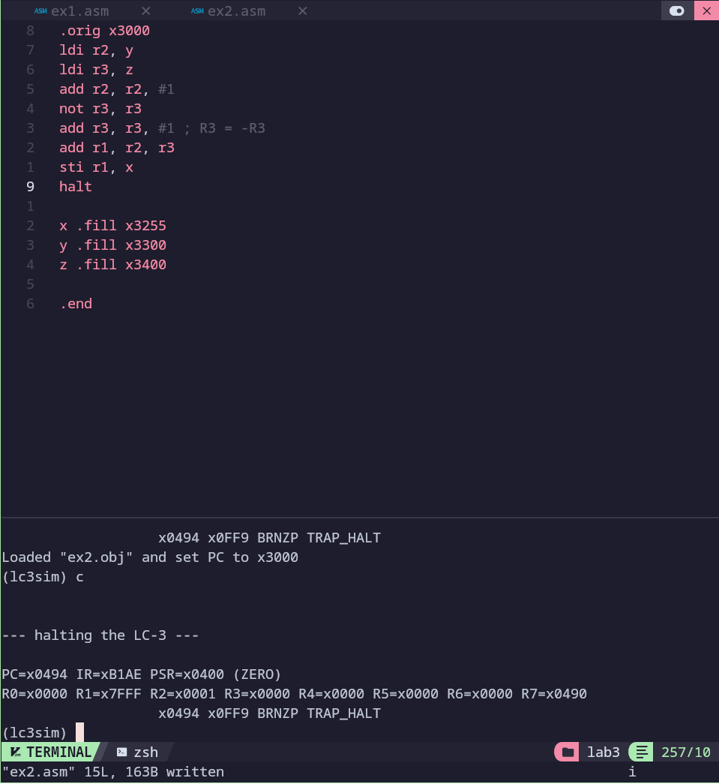
- After the program is ran, identify the value and locations of the registers to load and store the data. (Hint: LD and ST)
All start as 0 since we load no memory, the locations are at the labels x, y, and z. For r2, x3300, for r3, x3400, and r1 is stored at x3255
- Create an assembly program to perform the following: T = (A + B) + (C – 9).
You are required to use LD instruction in this program.
- A is located in R0, x3102
- B is located in R1, x3103
- C is located in R3, x3104
- T is located R5, x3105
Include appropriate comments. Save the program as Lab3Ex3.asm. Assemble, load and run the program.
- Provide screen captures that contain code from the Editor and Simulator after the program has been loaded and ran.
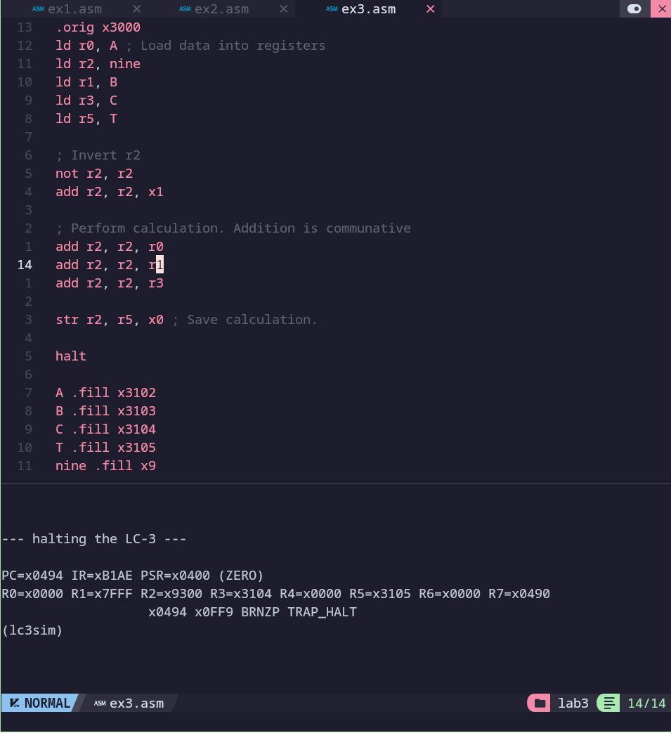
- Determine the location for T. See Simulator.
X3105? I am unsure as I don’t understand the instructions
- Create an assembly program to perform the following: P = Q = S = Z + hexadecimal 4D
Include appropriate comments. You can use any memory location. Save the program as Lab4Ex4.asm. Assemble, load and run the program.
- Provide screen captures that contain code from the Editor and Simulator after the program has been executed.
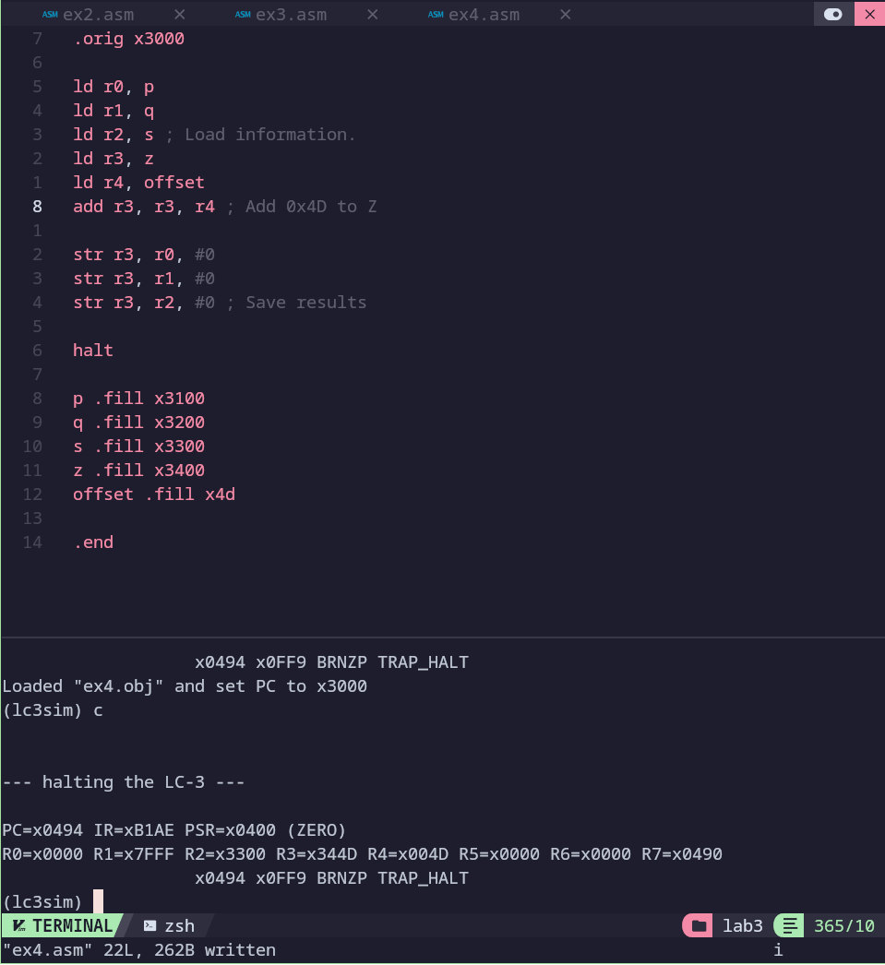
- Review the Simulator information. Note the location for Z.
x3400
- Based on your observation in the simulation of the program, compare and contrast this program to Exercise 4 program, such as instructions, addressing, and execution.
I am confused as this is exercise 4? It is using the variables as addresses instead of values?
- The below program incorporates conditional instructions, such as BRNz or BRNp.
- BR instruction branch to the code section indicated by LABEL, if the bit indicated by (n/z/p) has been set by a previous instruction: n:negative bit, z: zero bit, p:positive bit.
- RET is another instruction used in this program. RET returns from a subroutine using the value in R7 as the base address. It is also equivalent to JMP R7
- JSR instruction Put the address of the next instruction after the JSR instruction into R7 and jump to the subroutine indicated by LABEL.

Instructions for Conditions
- Create an assembly program as shown below:
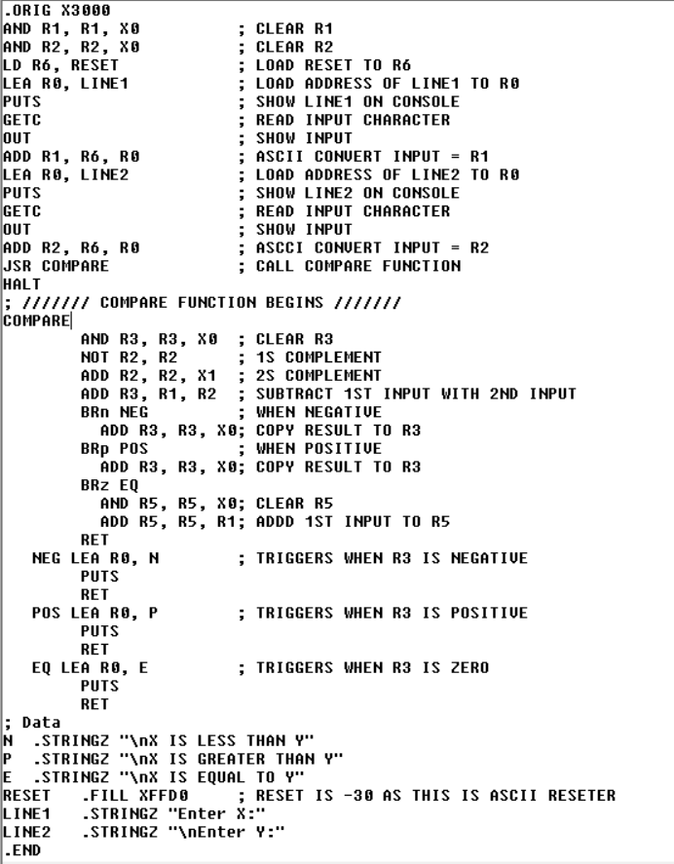
Include comments in the program. Save the program as Lab3Ex5.asm. Assemble, load and run the program. In the console, test the program by entering values for X and Y, using positive and negative values. Verify if the program display the correct output.
- Take the screen capture of the Editor and Console after the program has ran.
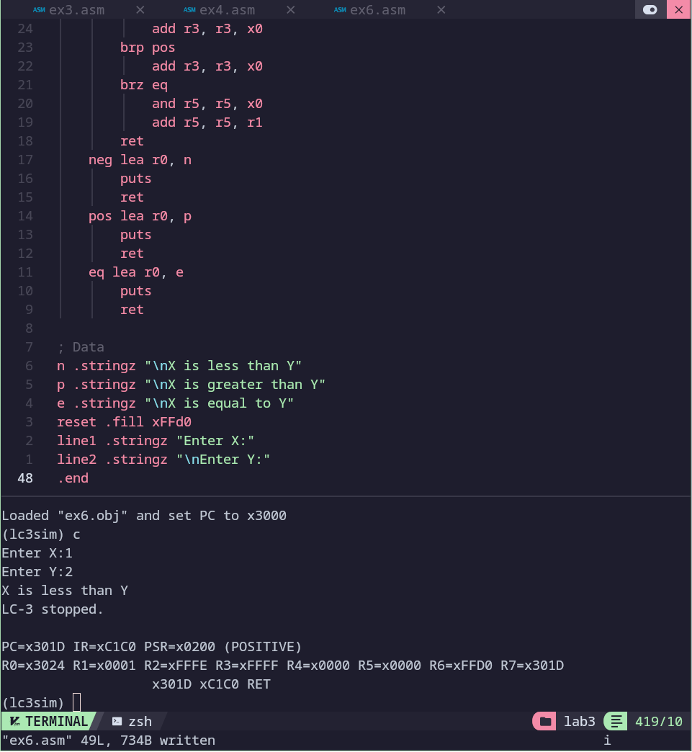
- How would you improve this program?
Adding sanitation to the input would be ideal, as right now, it can add and compare characters. Other than that, there isn’t much to improve. One might argue it would be better to do a substitution since the “X is” … “Y” is repeated, but that would just complicate the program and make it less readable.
Login Canvas and submit a document that contains screen captures and answers.

